update-this-filename-field

Standards Template (for Drafts)

Warning

This document is an unpublished, confidential work under development and shall not be referred to as a SMPTE Standard, Recommended Practice, or Engineering Guideline. It is distributed for review and comment; distribution does not constitute publication. Recipients of this document are strongly encouraged to submit, with their comments, notification of any relevant patent rights of which they are aware and to provide supporting documentation.

**Information for document editors**

* This template is designed to focus on content and not on style. This means that editors should:
  + Refrain from adding styles inline unless absolutely necessary
  + Refrain from modifying styles unless absolutely necessary
  + Use the sample styles & layouts for all headings, figures, tables and math
  + Use the supplied auto numbering styles for headings and annexes
* In the event that the content cannot be adequately expressed using this template, contact SMPTE HQ.
  + The blue text (like this sentence) is editing information or boilerplate. This is information used by SMPTE HQ for publication and should not be changed by the author.
  + The document editor must fill in the fields in black before submitting it to the Drafting Group.
  + The red text (like this sentence) is helpful information that is not part of the final document. This information **shall be deleted** prior to FCD Ballot.
  + The last page of this document has editing hints and a list of useful reference documents. :::

Project Group: *AHG-xml-docs*

Project Technology Committee: ST

Document type: *AG*

Document state: *WD*

Project chair(s): *Bruce Devlin*

Document editor(s): *Bruce Devlin*

Document number: *04*

Document title: *Standards Template (for Drafts)*

**Title Page**

This page will be provided by SMPTE HQ Staff.

See AG-16 clause 3.1 (Title Page), and ISO Directive Part 2 clause 11 (Title).

Proposed SMPTE Standard

This document is subject to change Copyright (C) 2020 SMPTE All rights reserved

# Foreword

See AG-16 3.2 (Foreword), and ISO Directive Part 2 clause 12 (Foreword).

SMPTE (the Society of Motion Picture and Television Engineers) is an internationally-recognized standards developing organization. Headquartered and incorporated in the United States of America, SMPTE has members in over 80 countries on six continents. SMPTE“s Engineering Documents, including Standards, Recommended Practices, and Engineering Guidelines, are prepared by SMPTE”s Technology Committees. Participation in these Committees is open to all with a bona fide interest in their work. SMPTE cooperates closely with other standards-developing organizations, including ISO, IEC and ITU. SMPTE Engineering Documents are drafted in accordance with the rules given in its Standards Operations Manual. This SMPTE Engineering Document was prepared by Technology Committee ST.

Normative text is text that describes elements of the design that are indispensable or contains the conformance language keywords: “shall”, “should”, or “may”. Informative text is text that is potentially helpful to the user, but not indispensable, and can be removed, changed, or added editorially without affecting interoperability. Informative text does not contain any conformance keywords.

All text in this document is, by default, normative, except: the Introduction, any section explicitly labeled as “Informative” or individual paragraphs that start with “Note:”

The keywords “shall” and “shall not” indicate requirements strictly to be followed in order to conform to the document and from which no deviation is permitted. The keywords “should” and “should not” indicate that, among several possibilities, one is recommended as particularly suitable, without mentioning or excluding others; or that a certain course of action is preferred but not necessarily required; or that (in the negative form) a certain possibility or course of action is deprecated but not prohibited.

The keywords “may” and “need not” indicate courses of action permissible within the limits of the document.

The keyword “reserved” indicates a provision that is not defined at this time, shall not be used, and may be defined in the future. The keyword “forbidden” indicates “reserved” and in addition indicates that the provision will never be defined in the future.

A conformant implementation according to this document is one that includes all mandatory provisions (“shall”) and, if implemented, all recommended provisions (“should”) as described. A conformant implementation need not implement optional provisions (“may”) and need not implement them as described. Unless otherwise specified, the order of precedence of the types of normative information in this document shall be as follows: Normative prose shall be the authoritative definition; Tables shall be next; then formal languages; then figures; and then any other language forms.

If this is a revision, a topical list of changes [should/shall be included here]

# Introduction

An Introduction section is Optional / Conditional

The introduction provides specific information or commentary about the technical content of the document, and about the reasons prompting its preparation. See AG-16 clause 3.3 (Introduction), AG-16 clause 4.2 (Conformance Terms), and ISO Directive Part 2 clause 13 (Introduction).

This section is entirely informative and does not form an integral part of this Engineering Document.

Your introduction text goes here.

[Editors notes: The following paragraph will be replaced with the appropriate patent information during the SMPTE Headquarters publication process.]

At the time of publication, no notice had been received by SMPTE claiming patent rights essential to the implementation of this Engineering Document. However, attention is drawn to the possibility that some of the elements of this document may be the subject of patent rights. SMPTE shall not be held responsible for identifying any or all such patent rights.

# 1 Scope

The scope clearly defines the subject of the document and the aspects covered, thereby indicating the limits of applicability of the document. See AG-16 clause 3.4 (Scope), and ISO Directive Part 2 clause 14 (Scope).

Your Scope Text

# 2 Normative References

The normative references clause lists, for information, those documents which are cited normatively in the document. See AG-16 clause 3.5 (Normative References), AG-16 clause 4.3 (Normative References to Standards and Recommended Practices), and the ISO Directives Clause 15 (Normative References).

The following Administrative Guideline contains provisions that, through reference in this text, constitute provisions of this standard. [Dated references require that the specific edition cited shall be used as the reference. Undated citations refer to the edition of the referenced document (including any amendments) current at the date of publication of this document. All Administrative Guideline are subject to revision, and users of this engineering document are encouraged to investigate the possibility of applying the most recent edition of any undated reference.

Your Normative References

# 3 Terms and Definitions

The terms and definitions clause provide definitions necessary for the understanding of certain terms used in the document. See AG-16 clause 3.6 (Terms and Definitions), AG-16 clause 4.4 (Terms and Definitions), and ISO Directive Part 2 clause 16 (Terms and Definitions).

Select one of the following sentences and delete the others:

a) For the purposes of this document, the following terms and definitions apply:

b) For the purposes of this document, the terms and definitions given in [external reference(s)] apply.

c) For the purposes of this document, the terms and definitions given in [external reference(s)] and the following apply:

d) No terms and definitions are listed in this document.

If sentence b) or d) is selected, nothing else appears in the Clause.

If sentence a) or c) is selected, one or more terms is defined in the clauses immediately following.

Your terms and definitions follow.

Your Terms and Definitions

# 4 Technical Content

These clauses include the technical content of the Engineering Document.

# 5 Headings and Lists

## 5.1 Heading 2

## 5.2 Heading 3

In this section, lists and headings are shown:

* An auto bullet list
  + With a nest
    1. And another nest
    2. And one more
  + Using numbered lists
    1. Here is a numbered list
    2. With 3 entries
    3. And a sub-level
    4. With 2 entries
    5. And a last entry

### 5.2.1 Another Heading 3

#### 5.2.1.1 This is heading 4

##### 5.2.1.1.1 And heading 5

###### 5.2.1.1.1.1 And heading 6

# 6 Style Recommendations

## 6.1 Notes

NOTE: This is purely informational

## 6.2 Examples

EXAMPLE: 5 oranges

## 6.3 Equations

The tone mapping offset, gain and gamma values shall be applied according to the equation:

|  |  |
| --- | --- |
| $y=(min(max(0,(x×g)+o),1))^{P}$ | ( 1 ) |

where y is the output value x is the input value g is the value of Tone Mapping Gain o is the value of Tone Mapping Offset p is the value of Tone Mapping Gamma

## 6.4 Figures

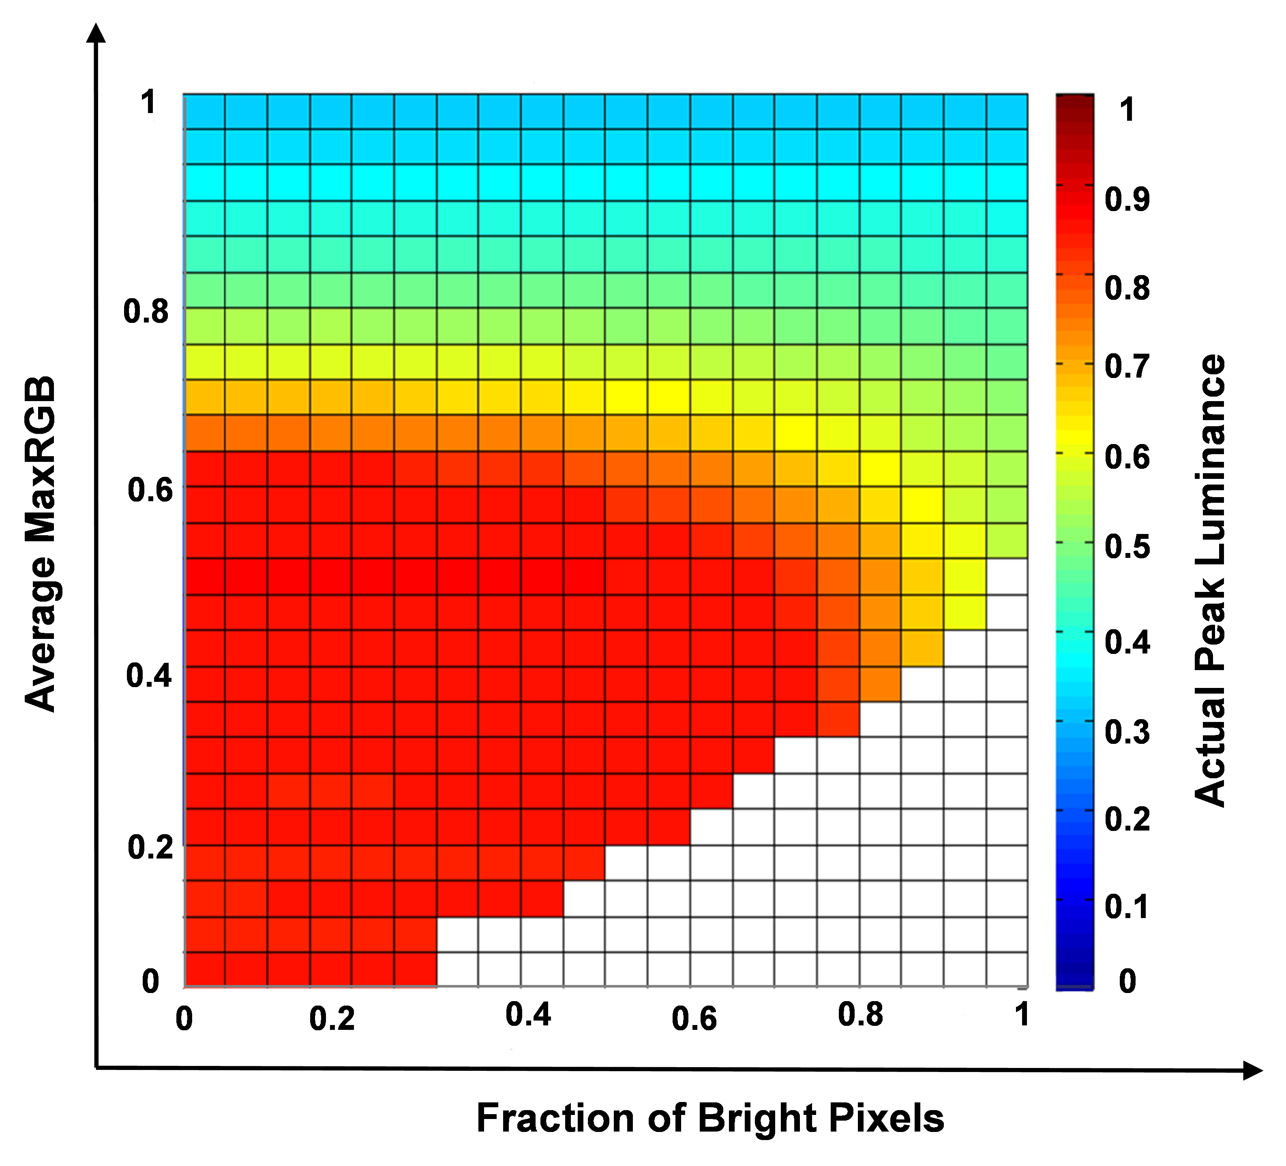

Two-dimensional LUT of actual peak luminance

## 6.5 Tables

Example Metadata sets with Time Intervals

|  |  |  |
| --- | --- | --- |
| Example set | TimeIntervalStart | TimeIntervalDuration |
| Application Set A | 0 | 2 |
| Application Set B | 0 | 3 |
| Application Set C | 5 | 2 |

# Annex A All Annexes are Numbered

## Annex A.1 Even the sub headings are numbered

By default syntax highlighting is used in code, XML and JSON.

<xs:schema attributeFormDefault="unqualified" elementFormDefault="qualified"  
 xmlns:xs="http://www.w3.org/2001/XMLSchema">  
 <!-- for restricting the termNote Attributes-->  
 <xs:simpleType name="LMTtermNoteLabelType">  
 <xs:restriction base="xs:string">  
 <xs:enumeration value="Language Group Name" />  
 <xs:enumeration value="Language Group Tag" />  
 <xs:enumeration value="Language Group Code" />  
 <xs:enumeration value="Audio Language Tag" />  
 <xs:enumeration value="Long Description 1" />  
 <xs:enumeration value="Long Description 2" />  
 <xs:enumeration value="Audio Language Display Name 1" />  
 <xs:enumeration value="Audio Language Display Name 2" />  
 <xs:enumeration value="Visual Language Tag 1" />  
 <xs:enumeration value="Visual Language Tag 2" />  
 <xs:enumeration value="Visual Language Display Name 1" />  
 <xs:enumeration value="Visual Language Display Name 2" />  
 <xs:enumeration value="Code" />  
 <xs:enumeration value="Notes" />  
 </xs:restriction>  
 </xs:simpleType>  
 <xs:simpleType name="relationTypeType">  
 <xs:restriction base="xs:string">  
 <xs:enumeration value="EQT" />  
 <!-- Equivalent To -->  
 <xs:enumeration value="BT" />  
 <!-- Broad Type -->  
 <xs:enumeration value="NT" />  
 <!-- Narrow Type -->  
 <xs:enumeration value="TT" />  
 <!-- Top Type -->  
 </xs:restriction>  
 </xs:simpleType>  
</xs:schema>

# Bibliography

A bibliography has no number